Electric Blower
EB450
GB

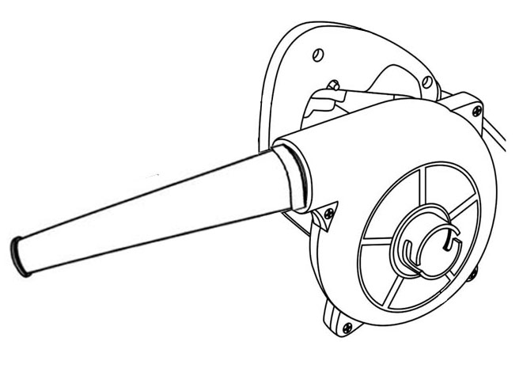

GB

Read this operators guide carefully, before using the machine. Ensure that you know how the machine works, and how it should be operated. Maintain the machine in accordance with the instructions, and make certain that the machine functions correctly. Keep this operator’s guide and other enclosed documentation with the machine.

TECHNICAL SPECIFICATIONS
Model | EB450
Voltage | 220-240V~ 50/60Hz
Rated power: | 450W
Speed: | 16,000/min
Air flow rate: | 2.5m³/min
Bag capacity | 0.6L
Weight: | 1.4kgs

Over view
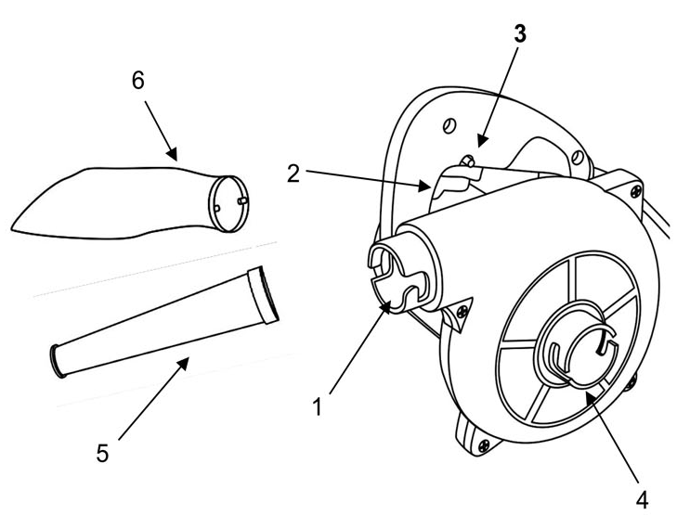

No. | Parts name
1 | Blowing connector
2 | Switch trigger
3 | Switch lock button
4 | Vacuum connector
5 | Nozzle (blower tube)
6 | Dust bag

General Safety Instructions for Electric Tools
This device is exclusively for private use! It is not fit for commercial use!
WARNING! Read all instructions. Failure to follow all instructions listed below may result in electric shock, fire and/or serious injury:
SAVE THESE INSTRUCTIONS
1)Work area
• Keep work area clean and well lit. Cluttered and dark areas invite accidents
• Do not operate machines in explosive atmospheres, such as in the presence of flammable liquids, gases or dust. Machines create sparks which may ignite the dust or fumes.
• Keep children and bystanders away while operating a machine. Distractions can cause you to lose control.
2)Electrical safety
• Machine plugs must match the outlet. Never modify the plug in any way. Do not use any adapter plugs with earthed (grounded) machines. Unmodified plugs and matching outlets will reduce risk of electric shock.
• Avoid body contact with earthed or grounded surfaces such as pipes, radiators, ranges and refrigerators. There is an increased risk of electric shock if your body is earthed or grounded.
• Do not expose machines to rain or wet conditions. Water entering a machine will increase the risk of electric shock.
• Do not abuse the cord. Never use the cord for carrying, pulling or unplugging the machine. Keep cord away from heat, oil, sharp edges or moving parts. Damaged or entangled cords increase the risk of electric shock.
• When operating a machine outdoors, use an extension cord suitable for outdoor use. Use of a cord suitable for outdoor use reduces the risk of electric shock.

3)Personal safety
• Stay alert, Watch what you are doing and use common sense when operating a machine. Do not use a machine while you are tired or under the influence of drugs, alcohol or medication. A moment of inattention while operating machines may result in serious personal injury.
• Use safety equipment. Always wear eye protection. Safety equipment such as dust mark, non-skid safety shoes, hard hat, or hearing protection used for appropriate conditions will reduce personal injuries.
•Avoid accidental starting. Ensure the switch is in the off position before plugging in. Carrying machines with your finger on the switch or plugging in machines that have the switch on invites accidents.
•Remove any adjusting key or wrench before turning the machine on. A wrench or a key left attached to a rotating part of the machine may result in personal injury.
•Do not overreach. Keep proper footing and balance at all times. This enables better control of the machine in unexpected situations.
• Dress properly. Do not wear loose clothing or jewellery. Keep your hair, clothing and gloves away from moving parts. Loose clothes, jewellery or long hair can be caught in moving parts.
• If devices are provided for the connection of dust extraction and collection facilities, ensure these are connected and properly used. Use of these devices can reduce dust related hazards.

4)Machine use and care
• Do not force the machine. Use the correct machine for your application. The correct machine will do the job better and safer at the rate for which it was designed.
•Do not use the machine if the switch does not turn it on and off. Any machine that can not be controlled with the switch is dangerous and must be repaired.
•Disconnect the plug from the power source before making any adjustments, changing accessories, or storing machines. Such preventive safety measures reduce the risk of starting the machine accidentally.
• Store idle machines out of the reach children and do not allow persons unfamiliar with the machine or these instructions to operate the machine. Machines are dangerous in the hands of untrained users.
• Maintain machines. Check for misalignment or binding of moving parts, breakage of parts and any other condition that may affect the machines operation. If damaged, have the machine repaired before use. Many accidents are caused by poorly maintained machines.
•Keep cutting tools sharp and clean. Properly maintained cutting tools with sharp cutting edges are less likely to bind and are easier to control.
• Use the machine, accessories and tool bits etc., in accordance with these instructions and in the manner intended for the particular type of machine, taking into account the working conditions and the work to be performed. Use of the machine for operations different from intended could result in a hazardous situation.

5)Service
• Have your machine serviced by a qualified repair person using only identical replacement parts. This will ensure that the safety of the machine is maintained.

OPERATION INSTRUCTIONS
Before Use
WARNING: Always disconnect from the power supply before carrying out any assembly, maintenance or cleaning.

Assemble the tube
- To attach the blower tube to the blower, line up the tube with the blowing connector as shown in below figure. Push the tube into the slot of blowing connector and turn the tube clockwise to lock it.
- To remove the blower tube, turn it anti-clockwise, then pull it.
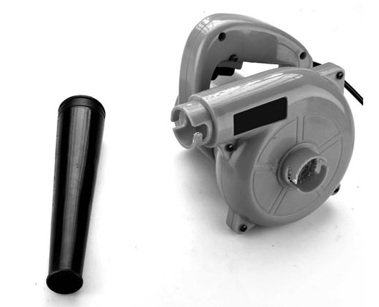
Slot of blowing connector

Assemble the dust bag

- Assemble the dust bag procedure is same as assemble the tube.
- When the machine be used as a vacuum, the dust bag should be attached on the blowing connector (1).

Operation
Switch on / off
The main voltage must correspond to the value specified on the label.
Switch on----Press the switch trigger (2) and hold it down. Press the lock button (3) to lock on the tool.
Switch Off--- Release the switch trigger (2).

Blowing
Attach the nozzle to the blowing connector (1) and rotate it to lock it in place.
Vacuum
Attach the nozzle (5) to the vacuum connector (4)
Attach the dust bag (6) to the blowing connector (1).
After each use the dust bag (6) must be emptied. Open the zip fastener of the bag and empty its contents.

MAINTENANCE
 WARNING! Always wear protective gloves druing maintenance operations. Do not carry out maintenance when the engine is running or hot.
WARNING! Use only manufacturer approved replacement parts, accessories and attachment. Failure to do so can cause possible injury and poor performance.

- Store the tool, user manual and accessories in a secure, dry place. This way you will always have the information ready.
- Keep the tool's air vents unclogged and clean at all times.
- Remove dust and dirt regularly. Cleaning is best done with a rag or brush.
- Never use caustic agents to clean plastic parts.
WARNING! Do not use cleaning agents to clean the plastic parts of the tool. A mild detergent on a damp cloth is recommended. Water must never come into contact with the tool.

