Electric Planer
EP710
GB

GB

Read this operators guide carefully, before using the machine. Ensure that you know how the machine works, and how it should be operated. Maintain the machine in accordance with the instructions, and make certain that the machine functions correctly. Keep this operator’s guide and other enclosed documentation with the machine.

TECHNICAL SPECIFICATIONS
Model | EP710
Rated power: | 710W
Speed: | 16,000/min
Max planning width | 82mm
Max planning depth | 1mm
Weight: | 2.5kgs

Over view

1.Depth adjustment knob 2. Switch trigger
3.locking button 4. Rear base
5.belt cover 6. Front base
7.dust outlet 8.parallel guide ruler locking knob
9.blade 10. Blade sharping fixture
11.blade setting gauge 12. Belt
13 carbon brush
General Safety Instructions for Electric Tools
This device is exclusively for private use! It is not fit for commercial use!
WARNING! Read all instructions. Failure to follow all instructions listed below may result in electric shock, fire and/or serious injury:
SAVE THESE INSTRUCTIONS
1)Work area
• Keep work area clean and well lit. Cluttered and dark areas invite accidents
• Do not operate machines in explosive atmospheres, such as in the presence of flammable liquids, gases or dust. Machines create sparks which may ignite the dust or fumes.
• Keep children and bystanders away while operating a machine. Distractions can cause you to lose control.
2)Electrical safety
• Machine plugs must match the outlet. Never modify the plug in any way. Do not use any adapter plugs with earthed (grounded) machines. Unmodified plugs and matching outlets will reduce risk of electric shock.
• Avoid body contact with earthed or grounded surfaces such as pipes, radiators, ranges and refrigerators. There is an increased risk of electric shock if your body is earthed or grounded.
• Do not expose machines to rain or wet conditions. Water entering a machine will increase the risk of electric shock.
• Do not abuse the cord. Never use the cord for carrying, pulling or unplugging the machine. Keep cord away from heat, oil, sharp edges or moving parts. Damaged or entangled cords increase the risk of electric shock.
• When operating a machine outdoors, use an extension cord suitable for outdoor use. Use of a cord suitable for outdoor use reduces the risk of electric shock.

3)Personal safety
• Stay alert, Watch what you are doing and use common sense when operating a machine. Do not use a machine while you are tired or under the influence of drugs, alcohol or medication. A moment of inattention while operating machines may result in serious personal injury.
• Use safety equipment. Always wear eye protection. Safety equipment such as dust mark, non-skid safety shoes, hard hat, or hearing protection used for appropriate conditions will reduce personal injuries.
•Avoid accidental starting. Ensure the switch is in the off position before plugging in. Carrying machines with your finger on the switch or plugging in machines that have the switch on invites accidents.
•Remove any adjusting key or wrench before turning the machine on. A wrench or a key left attached to a rotating part of the machine may result in personal injury.
•Do not overreach. Keep proper footing and balance at all times. This enables better control of the machine in unexpected situations.
• Dress properly. Do not wear loose clothing or jewellery. Keep your hair, clothing and gloves away from moving parts. Loose clothes, jewellery or long hair can be caught in moving parts.
• If devices are provided for the connection of dust extraction and collection facilities, ensure these are connected and properly used. Use of these devices can reduce dust related hazards.

4)Machine use and care
• Do not force the machine. Use the correct machine for your application. The correct machine will do the job better and safer at the rate for which it was designed.
•Do not use the machine if the switch does not turn it on and off. Any machine that can not be controlled with the switch is dangerous and must be repaired.
•Disconnect the plug from the power source before making any adjustments, changing accessories, or storing machines. Such preventive safety measures reduce the risk of starting the machine accidentally.
• Store idle machines out of the reach children and do not allow persons unfamiliar with the machine or these instructions to operate the machine. Machines are dangerous in the hands of untrained users.
• Maintain machines. Check for misalignment or binding of moving parts, breakage of parts and any other condition that may affect the machines operation. If damaged, have the machine repaired before use. Many accidents are caused by poorly maintained machines.
•Keep cutting tools sharp and clean. Properly maintained cutting tools with sharp cutting edges are less likely to bind and are easier to control.
• Use the machine, accessories and tool bits etc., in accordance with these instructions and in the manner intended for the particular type of machine, taking into account the working conditions and the work to be performed. Use of the machine for operations different from intended could result in a hazardous situation.

5)Service
• Have your machine serviced by a qualified repair person using only identical replacement parts. This will ensure that the safety of the machine is maintained.

OPERATION INSTRUCTIONS Plan depth adjustment
Turn the depth adjustment knob (1) to adjust, make sure the scale align at the small triangle on the housing.
Power ON/OFF
To start the tool, simply press the trigger (2). Release the trigger to stop. For continuous operation， press the trigger(2) and then press in the lock button(3). To stop the tool from the locked position, press the trigger (2) fully, then release it.
Fix the parallel guide ruler
Loosen the locking knob (8), insert the parallel guide ruler (14), then tighten the locking knob (8).

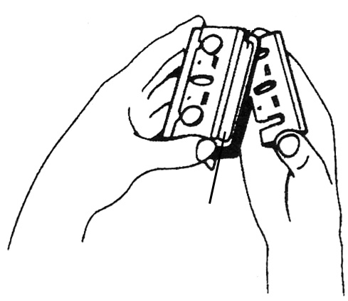
Sharpening planer blades
Sharpening holder
Fig.6
Always keep your blades sharp for the best performance possible. Use the sharpening holder to remove nicks and produce a fine edge. (Fig.6)

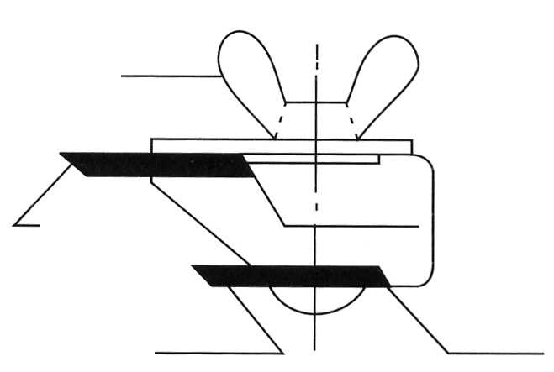
Wing nut
Blade A
Blade sharping fixture Side C
Blade B
Side D
Fig.7

First， loosen the two wing nuts on the holder and insert the blades (A) and (B)， so that they contact the sides (C) and (D). Then tighten the wing nuts. (Fig.7)

Immerse the dressing stone in water for 2 or 3 minutes before sharpening. Hold the holder so that the blades both contact the dressing stone for simultaneous sharpening at the same angle.

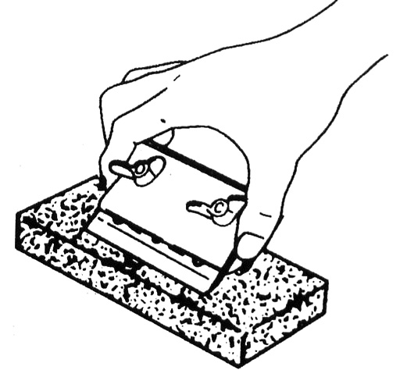
Fig.8

Fix the blade
Put the sharped blade in the blade setting gauge(11), then fix the blade in the machine
Replace the belt
Loosen the screws (16), take out the belt cover. Then replace the belt (12).

Replace carbon brush
If big spark, or the carbon brush length is 3-5mm, you should replace the carbon brush. Use the screwdriver (16) to take out dust cover, brush cover(18). Then replace the carbon brush (13).
ENVIRONMENTAL PROTECTION
Waste electrical products should not be disposed of with household waste.
Please recycle where facilities exist.
Check with your local authority or retailer for recycling advice.

EP710 exploded view
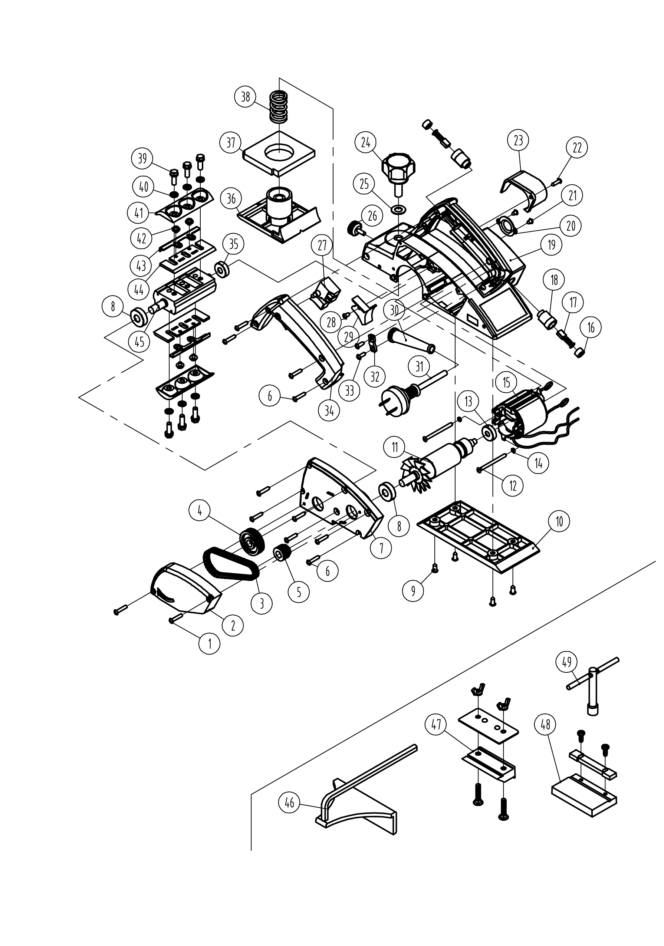

EP710 part list
number | Part list | number | Part list
1 | Screw M4X22 | 26 | Locking knob
2 | Belt cover | 27 | Switch
3 | Belt | 28 | Screw ST4.2X8
4 | Big pulley | 29 | Wind guide
5 | Small pulley | 30 | Cable sleeve
6 | Screw ST4.2X20 | 31 | Cable
7 | Side cover | 32 | Cable press board
8 | Bearing 6000 | 33 | Screw ST4.2X14
9 | Screw ST4.8X12 | 34 | Handle cover
10 | Rear base | 35 | Bearing 608
11 | Rotor | 36 | Front base
12 | Screw ST4.2X60 | 37 | Sponge
13 | Bearing 627 | 38 | Spring
14 | Spring washer | 39 | Bolt M6X18
15 | Stator | 40 | Washer
16 | Brush cover | 41 | Big press board
17 | Carbon brush | 42 | Screw M4X4
18 | Brush holder | 43 | Small press board
19 | Housing | 44 | Blade
20 | Bearing press board | 45 | Blade holder
21 | Screw ST4.2X48 | 46 | Guide ruler
22 | Screw ST4.2X16 | 47 | Blade sharping fixture
23 | Dust outlet | 48 | blade setting gauge
24 | Depth adjustment knob | 49 | Spanner
25 | Washer

